Basic Information
Product Category |  | High Bay |  | Product Name |  | Module Hight Bay Lamp
Product Code |  | DS-BY-50W |  | Applicable Safety Standards |  | GB-7000.1
Fixture Picture
Fixture Structure Size
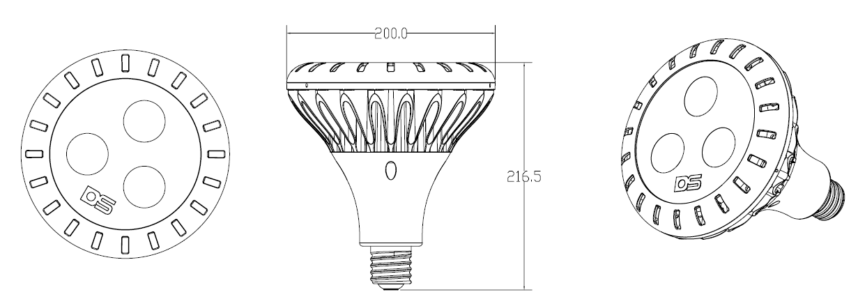

Technical Specifications
Fixture Parameters | Size |  | H215*Φ200mm |  | Housing Materials |  | Aluminium Alloy+PBT
 | Net Weight |  | 2.3Kg |  | Appearance Color |  | White
 | Whole Lamp IP |  | IP65 |  | Packing Specification |  | 1PCS/ Carton
 | Installation Mode |  | E40 lamp holder
Light Source Parameters | LED Brand |  | DSBJ |  | LED Type | DS-COB
 | LED Q.T.Y. |  | 3PCS |  | LED Color Temperature | 5500~6000
 | LED CRI |  | ＞70 |  | LED Lifespan (L70) | ＞30000H
Optical Parameters | Light Distribution Type |  | Cone |  | Extraction Mode | Twice Symmetrical
 | Total Light Flux |  | ＞4250 lm |  | Optical Efficiency of the Whole Lamp | ＞85 lm/w
 | CRI |  | ≥70 |  | CCT of the Whole Lamp | 5700K±300K
Electricity Parameters | Power(W) |  | 50W
 | Input Voltage |  | 100~240V
 | Input Voltage Frequency |  | 50/60Hz
 | Input Current |  | <1A
 | Power Factor |  | ＞0.9
Other Parameters | Applicable Temperature /Humidity |  | -20~55℃/≤95%RH |  | Storage Temperature /Humidity | -25～60℃/≤95%RH
 | Level of Electric Protection |  | Ⅱ |  | Driver Location | Rear-mounted
Note：Size Specification Tolerance±5mm
Weight Specification Tolerance±0.5 Kg

Light Distribution Curve
Effective Average Illumination

Producer | DXT | Verifier | TOM | Date | Nov.23,2012

